**7-Speeds Electrical Beater (white)**

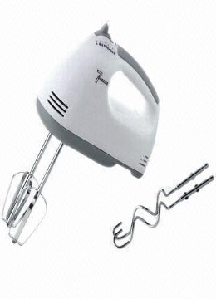

**Key Features  
  
 Brand Warranty  
 4 - Speed Hand Mixer  
 Power: 200 watts  
 Price per Unit: $150/-**

**CORPORATE OFFICE**

    1300 E. Control Tower Rd.  
    Suite 216 Block L3  
    Englewood CO 80112  
 Phone: 720.974.7878  
    Toll Free: 1.877.929.7878  
    Email: [info@choicescreening.com](mailto:info@choicescreening.com)